

Year 8 Science
Biology 2 Test: Systems

SECTION 1: MULTIPLE CHOICE (1 mark each)
Circle your answer on the multiple choice answer sheet.

- What makes up most of the volume of blood?
  - red blood cells
  - white blood cells
  - platelets
  - plasma

- The trachea belongs to which system?
  - respiratory
  - reproductive
  - excretory
  - circulatory

- Oxygen is mainly carried in the blood in the
  - Red blood cells
  - Platelets.
  - White blood cells.
  - Alveoli

- A component of the heart that prevents the reverse flow of blood is called the:
  - vena cava
  - right atrium.
  - atrioventricular valve.
  - aorta.

- Which statement is false?
  - The pistil (or female part) of the flower contains the stigma, style and ovary.
  - The ovary produces ovules (or egg cells).
  - When fertilised, the ovules will become seeds and the ovary will become fruit.
  - The ovary produces nectar and pollen

- Which of the following is the smallest type of blood vessel?
- Capillaries
- Arteries
- Arterioles
- Veins.

The next three questions refer to the following diagrams:
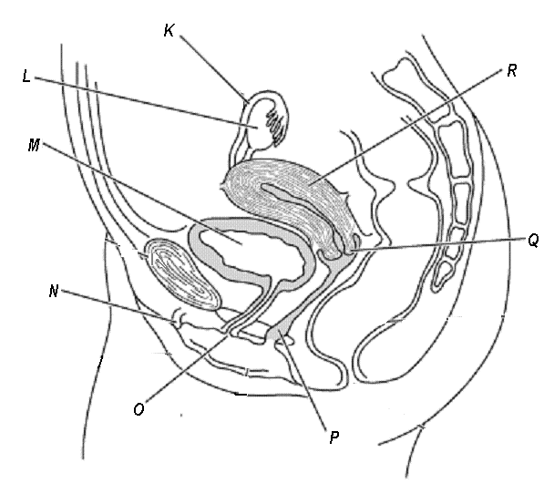
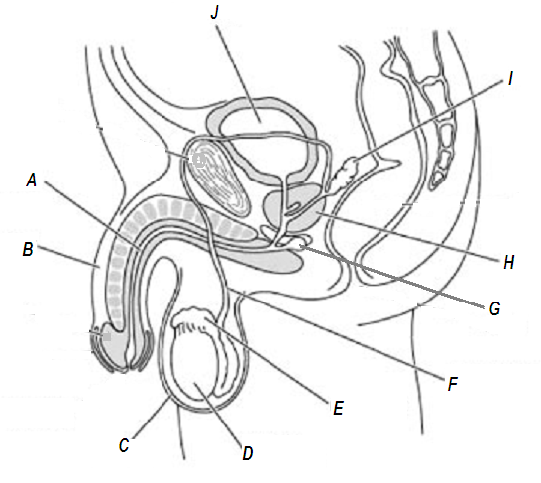

- The structure labelled E is the
  - epididymis
  - testis
  - sperm duct
  - prostate

- The structure labelled M is the
  - uterus
  - vagina
  - Fallopian tube
  - bladder

- The male and female urethra are labelled
  - A and O
  - A and P
  - F and O
  - F and P

- The plant equivalent of sperm is
a) anthers
b) ovules
c) stigma
d) pollen

- Which statement is true?
  - The majority of gas exchange in humans occurs in the mouth.
  - The majority of gas exchange in humans occurs in the alveoli.
  - The majority of gas exchange in humans occurs in the rib cage.
  - The majority of gas exchange in humans occurs in the trachea

- Which statement about the phloem is correct
- It carries sugars from the roots to the leaves
- It carries ions from the leaves to the roots
- It carries water from the roots to the leaves
- It carries sugars from leaves to all other plant parts.

- What is the loss of water vapour from the leaves called?
- Evaporation
- Osmosis
- Transpiration
- Diffusion

- A hinge joint is located in the human body at the
- Base of the thumb
- Base of the skull
- Joint between the femur and the tibia
- Joint between the pelvis and the femur.

- Which of the following pairs have the same role in human reproduction as they do in plant reproduction?
- Testis and stigma
- Fallopian tube and fruit
- Egg and anther
- Sperm and pollen

2019 Biology 2
SYSTEMS

Multiple Choice Answer Sheet

Name: ___________________ Year: 8

Multiple Choice – 15 questions.
Circle your choice. If you change your mind, scrub your choice out and circle the one you want. If it is messy, clearly write your choice next to question.

1. A B C D

2. A B C D

3. A B C D

4. A B C D

5. A B C D

6. A B C D

7. A B C D

8. A B C D

9. A B C D

10. A B C D

11. A B C D

12. A B C D

13. A B C D

14. A B C D

15. A B C D

Correct answers: ______ / 15 questions

SECTION 2: WRITTEN 25 MARKS
Write your answers in the spaces on the answer sheet provided.

- a. Label the following diagram of the heart (7 marks)

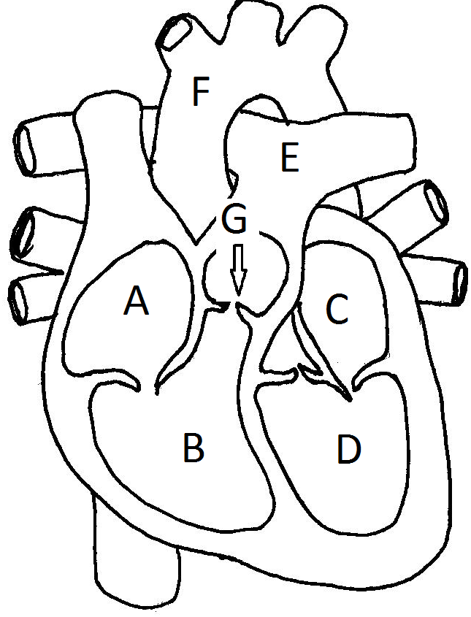

A - __________________

B - __________________

C - __________________

D - __________________

E - __________________

F - __________________

G - __________________

b. Veins usually carry deoxygenated blood. Explain why the pulmonary vein is an exception. (2 marks)

__________________________________________________________________________________________________________________________________________________________________________________________________________________________________________________________________________________________________________________________________________

2. a. Label the following diagram of the respiratory system (3 marks)

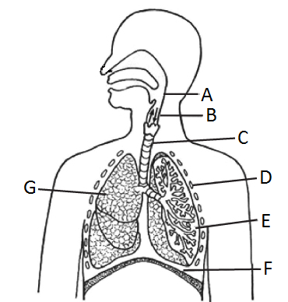

A - ______________________

C - ______________________

D - ______________________

E - ______________________

F - ______________________

G - ______________________

b. What is the shape and purpose of the cartilage found in the trachea?
(2 marks)

___________________________________________________________________________________________________________________________________________________________________________________________________

3. a. Label the following diagram (3 marks)

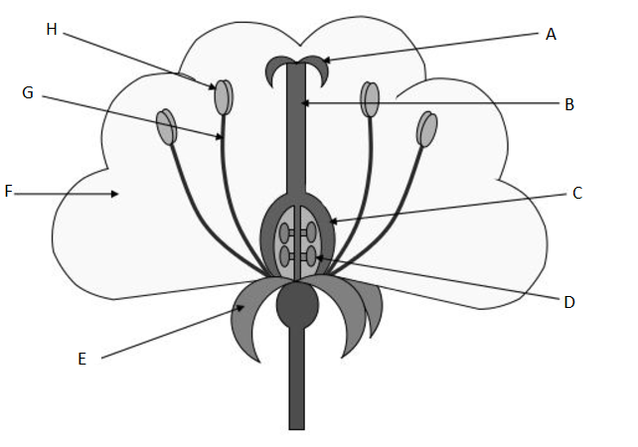

A - __________________

B - __________________

C - __________________

D - __________________

G - __________________

H - __________________

b. Not all plants depend on flowers to reproduce. Name a method of reproduction a plant may use to reproduce that does not involve a flower. Use an example explain the method. (3 marks)

_____________________________________________________________________________________________________________________________________________________________________________________________________________________________________________________________________________________________________________________________________

4. Complete the following table. (5 marks)

 | Asexual | Sexual
Definition | A form of reproduction where one parent produces the offspring
Advantage

Disadvantage

END OF TEST (Total 40 MARKS)

